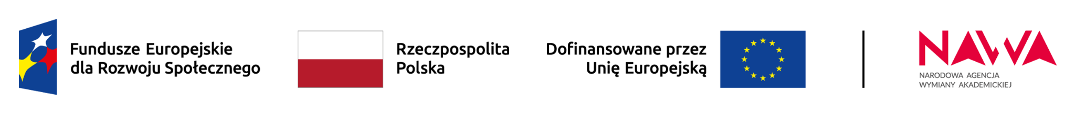

**PROM program application**

1. Name:
2. Surname:
3. Status: ◻ student ◻ PhD student ◻ Researcher
4. Faculty:
5. University:
6. Address/Country (to be filled in by external applicants):
7. Activity (please check the appropriate box)

* Internship/Workshop
* Planned dates:
* Host institution:
* Name and email of the internship supervisor:
* Conference
* Planned dates:
* Host institution:
* Conference name:
* Conference fee:
* Participation in (for international students and PhD candidates):
  + I-HOW JWST Hands-On Workshop for Central and Eastern Europe 2025
  + Molecular Excited States (MolEx) Workshop
  + Plant-microbial interactions in saline areas
  + M3-S „Applied polymers, nanomaterials, membranes, and composites”

8. Requested amount (calculated based on the information provided in Annex 1 to the regulations):

*I am applying to participate in the international scholarship exchange project for doctoral students and academic staff at Nicolaus Copernicus University (NCU) and hereby declare that I have read the Project Regulations.*

*I confirm that I have read and accept the content of the information clause on the processing of personal data within the project for the international scholarship exchange for doctoral students and academic staff at NCU:*

*The Nicolaus Copernicus University in Toruń with its registered office at Gagarina 11 will be the administrator of your personal data.*

*Your personal data shall be processed pursuant to Article 6.1.(f) of Regulation 2106/679 of the European Parliament and of the EU Council of 27 April 2016 on the protection of natural persons with regard to the processing of personal data and on the free movement of such data and on repealing Directive 95/46/EC (GDPR), i.e. in the legitimate interests including:*

*• efficient organisation of the call,*

*• deciding on the results of the call and awarding funding,*

*• possibility of establishing contact with the participants of the call.*

*With your consent, your name and surname will also be processed for the purpose of publishing information about the winners at www.fizyka.umk.pl/prom and www.fizyka.umk.pl/en/prom-eng. Please note that if you have given your consent, you have the right to withdraw it at any time; however, this will not affect the processing that was carried out before the withdrawal.*

*The personal data provided by you will be kept until the date on which the possibility of pursuing claims in connection with the organization of the call ceases to exist, but no longer than 3 months from the date of deciding on the results of the call.*

*You have the right to request access to your personal data, to rectify, erase or restrict processing of your personal data, as well as the right to object to its processing.*

*Providing your personal data is voluntary, but refusing to provide it or objecting to the processing of your personal data will prevent you from taking part in the call and otherwise has no other effects.*

*You have the right to lodge a complaint with a supervisory authority.*

*Your personal data will not be passed on to other entities.*

*If you wish to contact the University on matters relating to the processing of your personal data, in particular in relation to making a request to exercise your rights, please use the email address: IOD@umk.pl or write to the address: UMK w Toruniu, ul. Gagarina 11, 87-100 Toruń, with the reference 'IOD'.*

Name and Surname Date Signature